Chapter 8, Solution 23.

Let C_{o} = C + 0.01. For a parallel RLC circuit,

α = 1/(2RC_{o}), ω_{o} = 1/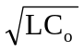

α = 1 = 1/(2RC_{o}), we then have C_{o} = 1/(2R) = 1/20 = 50 mF

ω_{o} = 1/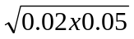 = 141.42 > α (underdamped)

C_{o} = C + 10 mF = 50 mF or C = 40 mF

